 | 12.1.54 Editors - Geometry Nodes Editor - Header - Add Menu - Generate
Table of content
Detailed table of content 1
Add menu - Generate 2
Array 2
Curve to Tube 3
Scatter on Surface 3

Detailed table of content
Detailed table of content
Detailed table of content 1
Add menu - Generate 2
Array 2
Curve to Tube 3
Scatter on Surface 3

Add menu - Generate

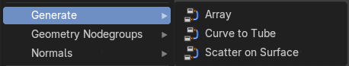
The nodes in this submenu are node groups. They use the regular single nodes under the hood.
It is virtually impossible to document these nodes in detail. So we will just list them.
When you double click the header, then you will enter the first level of the group. When you then press tab, or click again at the header, then you will reach the single nodes.




To leave the group you can use the breadcrumb up left in the header. These breadcrumbs are clickable. Or the Parent Node Tree button up right in the header.

Array
Generate and manage an array of elements.

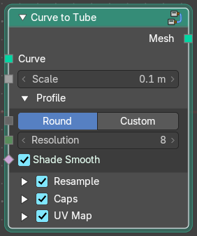
Curve to Tube
Convert a curve to a tube geometry.

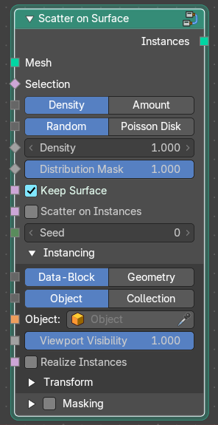
Scatter on Surface
Adds scattering to a polygon surface.

